

Technical Data Sheet
Sel Dış Tic. ve Kimya San. A.Ş.

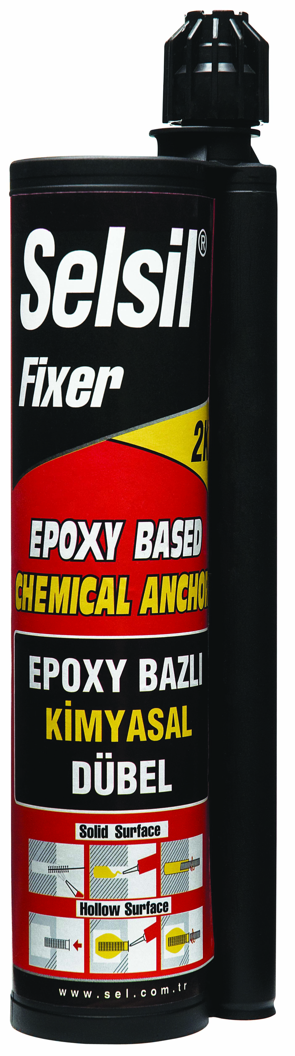 0895 Epoxy Based Chemical Anchor

Selsil Fixer Epoxy Based Chemical Anchor
1. Product Description
Two component, constituted resin and hardener, epoxy acrylate based chemical anchor system.

2. Properties
- Fast curing
- Thioxotropik, don’t make flow.
- Material is easily applicable with special gun.
- Material color remains constant.

3. Technical Information
Specific Gravity: 1,62±0,03 kg/L
Complete Curing(20°C): 7 days
Mixture Ratio(volume): Component A: % 90
Component B: % 10
Curing Time
Temperature | Using Time | Curing Time
5 °C | 25 min | 2–3 hours
20 °C | 6 min | 1 hour
30 °C | 4 min | 30 min
35 °C | 2 min | 25 min
Tensile Load For Concrete
Ore Diameter (mm) | Min. Perforation Diameter (mm) | Hole Depth (mm) | Min. Tensile Load (kN)
8 | 10 | 80 | 7
10 | 12 | 100 | 11
12 | 14 | 120 | 16
* Values for C35 Ribbed İron

Chemical Resistance’s Table
Substance | Resistance
Diesel oil | It can exposure for long -time
Acetic acid (%5) | It can exposure for intermittent
Sulphuric acid(%25) | Not recommended/It can exposure for very short time
Salt water | It can exposure for long -time
Caustic soda (%10) | It can exposure for long -time
Methanol | Not recommended

4. Application Details
Application Temperature: +5 °C ile +35 °C
Temperature Resistance: -30 °C ile +100 °C

*Remove the cover of the cartridge.
*Place the special mixer on the tip of the cartridge. Don’t use without mixer.
*Place the product in special cartridge gun.
*Make a hole appropriate to the diameter and depth of the anchor by using a driller.
*Purify the hole from dust and dirt by using a brush or air pomp.
*Grease and dust don’t exist sure of in hole after place anchor.
*Squeeze the product until it becomes grey (about 10–15 cm) and don’t use this part.
*The product about fifty fifty filled in hole with special gun.
*Anchorage material to turn round slowly place.
*Product’s curing time must complete for service to open.

Selsil Fixer Epoxy Based Chemical Anchor is used for;
- Product is used in shoot planting works for concrete and rock walls
- High load exposed to for anchorage and montage applications.

5. Packaging
345 ml cartridges
345 ml (A+B) x 16 per box

6. Colors
Component A: Green
Component B: Grey or Black

7. Shelf Life
Store the product in cool places away from direct sunlight.
The shelf life is 12 months at temperatures between +5°C and +25°C.

8. Caution
Keep out of reach of children. Avoid contact with skin and eyes.
Use in well-ventilated places. Don’t breathe vapors.
Do not smoke when using the product.

9. Health and Safety
For more information and advice on the safe handling, storage and disposal of chemical products, users shall refer to the most recent Material Safety Data Sheet containing, physical, ecological, and toxicological and other safety related data.

